Programming Fundamentals – Lab 06 Tasks

1. Student Attendance Counter (For Loop – Known Iterations)
A teacher wants to record attendance for 30 students in a class. Write a C program that uses a for loop to input attendance status (1 = Present, 0 = Absent) for each student and calculate the total number of students present.
Code:
int main(){
int attendance;
int totalpresent=0;
for(int i=1;i<=10;i++){
printf("enter student attendance = ",i);
scanf("%d",& attendance);
if(attendance==1){
totalpresent++;
}
}
printf("total present %d",totalpresent);
return 0;
}
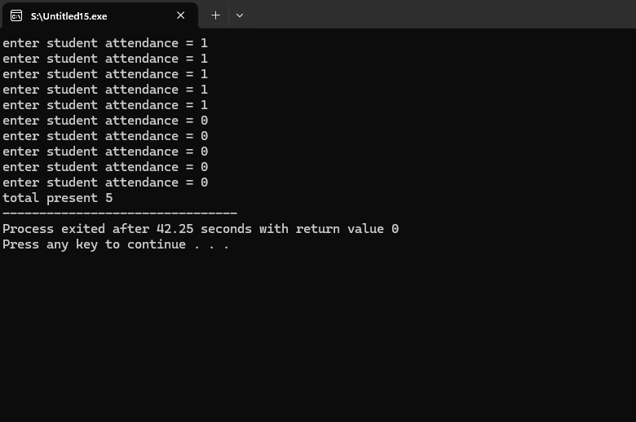

2. ATM Withdrawal System (While Loop – Condition Based)
An ATM allows a user to withdraw money until their balance becomes zero or negative. Write a C program using a while loop that keeps asking the user to enter the withdrawal amount and deducts it from the balance until the balance is exhausted.
Code:

int main() {
int balance=12763, withdraw;

while(balance > 0) {
printf("Current balance: %d\n", balance);
printf("Enter withdrawal amount: ");
scanf("%d", &withdraw);

balance = balance - withdraw;
}

printf("Balance exhausted!\n");
printf("Final balance: %d\n", balance);

return 0;
}
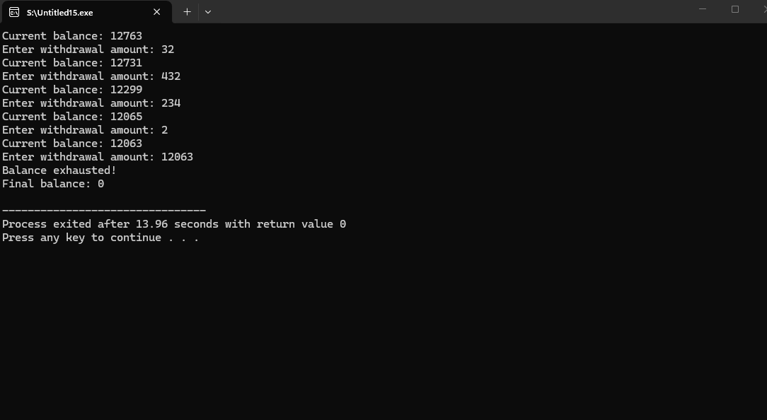

3. Password Retry System (Do-While Loop – At Least One Execution)
A system requires a user to enter a password. The correct password is 1234. Write a C program using a do-while loop that keeps asking the user to enter the password until the correct one is entered.
Code:
int main() {
int input;

do {
printf("Enter password: ");
scanf("%d", &input);

if(input != 1234) {
printf("Incorrect password. Try again.\n");
}

} while(input != 1234);

printf("correct pass");

return 0;
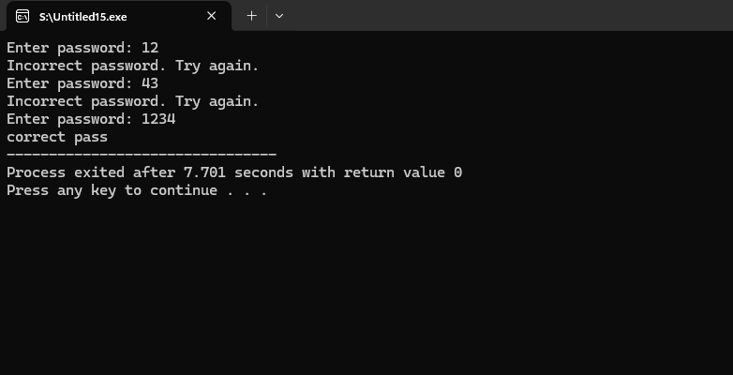

4. Sum of First N Natural Numbers (For Loop)
A user enters a number N. Write a C program that uses a for loop to calculate and display the sum of the first N natural numbers.
Code:
int main(){
int n,sum=0;
printf("input a number = ");
scanf("%d",&n);
for(int i=1;i<=n;i++){
sum=sum+i;
}
printf("sum of n number is %d",sum);
return 0;
}
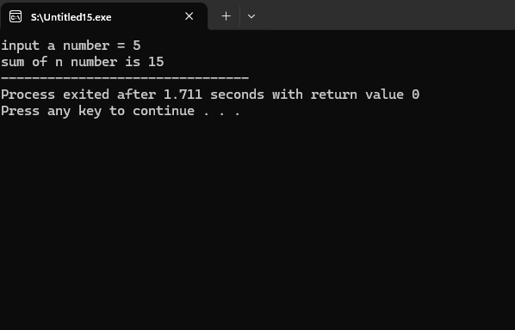
5. Temperature Monitoring System (While Loop – Dynamic Input Handling)
A weather station records temperature readings. The program should continuously accept temperature values until the user enters -999 (sentinel value). Use a while loop to calculate the average temperature of all valid inputs.
Code:
int main() {
float temp, sum = 0;
int count = 0;
printf("Enter temp= ");
scanf("%f", &temp);

while (temp != -999) {
sum =sum+ temp;
count++;
scanf("%f", &temp);
}

if (count > 0) {
printf("Average Temperature = %f\n", sum / count);
} else {
printf("No valid temperature readings entered.\n");
}

return 0;
}
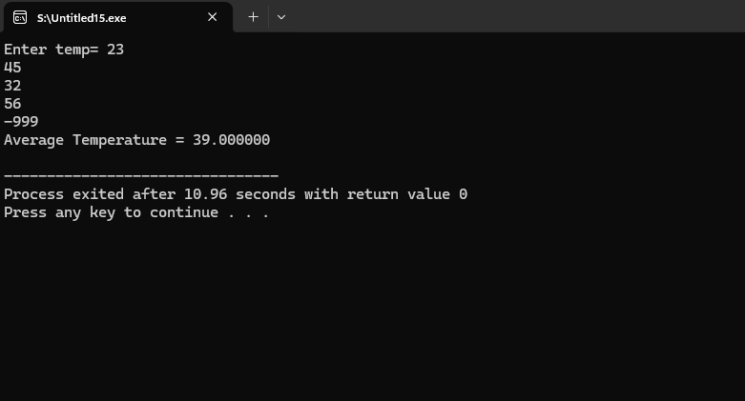
6. Multiplication Table Generator (For Loop – Controlled Iterations)
Write a C program that takes a number from the user and prints its multiplication table up to 10 using a for loop.
Code:
int main(){
int n,table;
printf("enter integer = ");
scanf("%d" ,&n);
for(int i;i<=10;i++){

table=n*i;
printf("%d x %d = %d\n", n,i,table);
}

return 0;
}
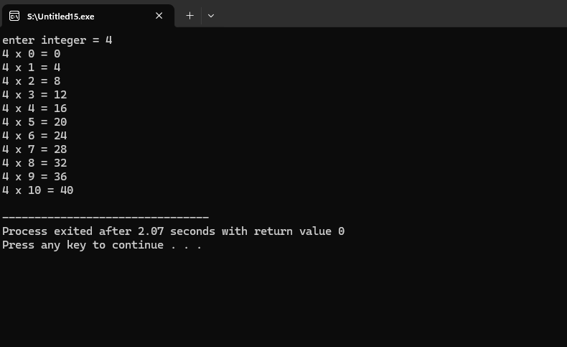

7. Menu-Driven Calculator (Do-While Loop – Exit Controlled Loop)
Design a simple calculator that shows a menu:
- Addition
- Subtraction
- Exit
The program should continue to display the menu after each operation until the user chooses Exit. Use a do-while loop to implement this behaviour.

Code:
int main(){
int i,n,input,result;

do{
printf("1.addition\n");
printf("2.subtraction\n");
printf("3.exit\n");
printf("enter input= ");
scanf("%d", &input);
switch (input){
case 1:
printf("enter two numbers= ");
scanf("%d %d",&i,&n);
result=i+n;
printf("result is %d\n", result);
break;

case 2:
printf("enter two numbers= ");
scanf("%d %d",&i,&n);
result=i-n;
printf("result is %d\n", result);
break;

case 3:
printf("you choose exit");
break;
default:
printf("invalid input try again\n");

}
} while(input !=3);
return 0;
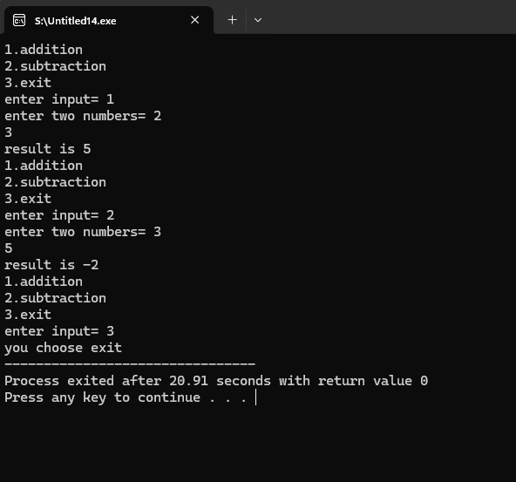

8. Number Guessing Game (While Loop – Control Flow Management)
Create a number guessing game where the correct number is 7. The user keeps entering guesses until they guess the correct number. Use a while loop and display appropriate messages ("Too High", "Too Low", "Correct!").
Code:
int main(){
int n=7,guess;
printf("input your guess= ");
scanf("%d",&guess);
while(guess!= n){
if(guess>n){
printf("guess is too high\n");
}
else if (guess<n){
printf("guess is too low\n");
}
printf("guess again= ");
scanf("%d",&guess);
}
printf("correct guess\n");
return 0;
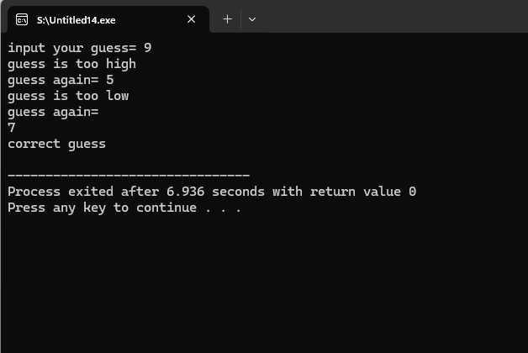

9. Factory Production Planning System (For Loop – Logical Iteration & Multiplicative Growth)
A factory produces customized gift boxes. The manager receives an order to produce N boxes, where each box requires the number of decorative items equal to its box number.
For example:
- Box 1 requires 1 decorative item
- Box 2 requires 2 decorative items
- Box 3 requires 3 decorative items
… and so on until Box N
Write a C program that:
- Takes the number of boxes N as input
- Uses a for loop to calculate the total number of decorative items required
- Displays the final total

Code:

int main(){

int n;
int items=0;
printf("enter the number of boxes= ");
scanf("%d",&n);
for(int i=1;i<=n;i++){
items=items+i;
}
printf("the total number of decorative items are %d\n",items);
return 0;
}
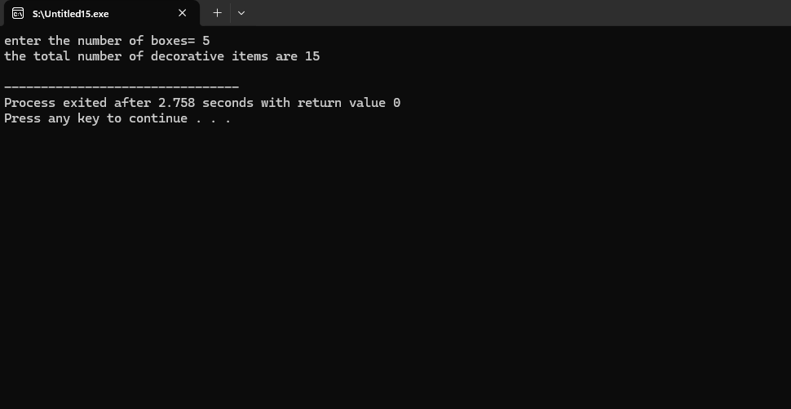

10. University Data Analysis System (While Loop – Logical Classification & Sentinel Control)
A university is analyzing student test scores for research purposes. The system should continuously accept student scores (0–100).
The program must:
- Continue taking input until the user enters -1 (sentinel value)
- Count how many students scored:
  - Distinction (≥ 75)
  - Pass (50–74)
  - Fail (< 50)
- Display the total number of students in each category
Use a while loop to control the execution and ensure proper classification logic.
Code:
int main(){
int score;
int distinction=0;
int pass=0;
int fail=0;
printf("enter score");
scanf("%d",&score);
while(score !=-1){
if(score>=75){
distinction++;
}
else if(score>50 && score<=74){
pass++;
}
else if(score<50){
fail++;
}
else{
printf("invalid score");
}
scanf("%d",&score);
}
printf("the total number of distinctions are %d\n",distinction);
printf("the total number of passes are %d\n", pass);
printf("the total number of fail are %d\n", fail);
return 0;
}
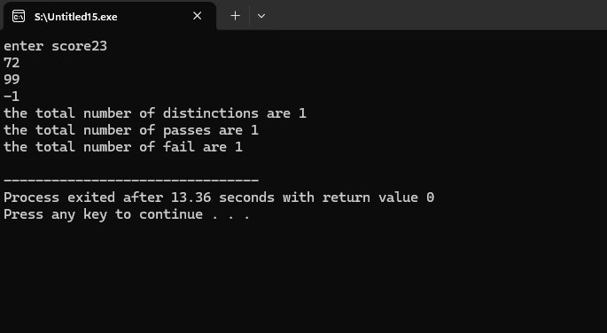
11. Online Shopping Cart Checkout System (Do-While Loop – Exit Controlled & User Choice Based)
An online shopping system allows customers to continuously add products to their cart.
Each time:
- The user enters the price of a product.
- The system adds it to the total bill.
- After each entry, the system asks whether the customer wants to add another product (1 = Yes, 0 = No).
The program must:
- Use a do-while loop so that at least one product is entered.
- Calculate the total bill amount.
- Apply a 5% discount if the total bill exceeds 5000.
- Display the final payable amount.
Code:
int main(){
float totalbill=0,price;
int decision;
do{
printf("enter the price of product ");
scanf("%f", &price);
totalbill=totalbill+price;

printf("do yo want to continue shopping [0 for NO and 1 for YES]");
scanf("%d", &decision);
} while(decision==1);
if(totalbill>5000){
totalbill=totalbill -(totalbill*0.05);
}
else{
totalbill=totalbill;
}
printf("the final amount payable is %f",totalbill);
return 0;
}
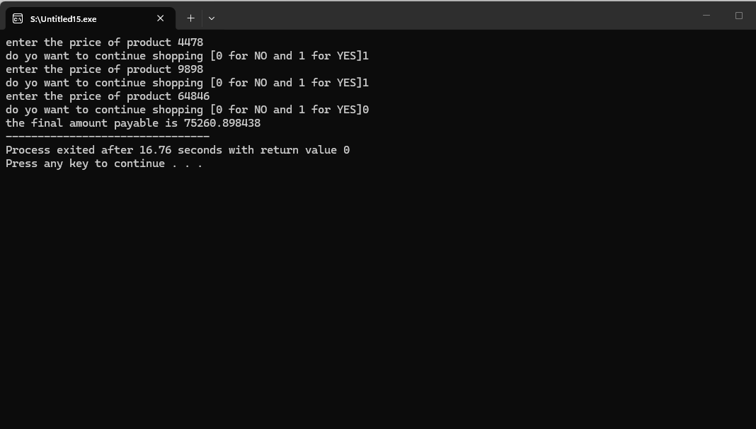

12. Bus Seat Reservation Monitoring System (While Loop – Conditional Termination & Logical Control)
A bus has 40 seats available. Passengers arrive one by one to reserve a seat.
The system should:
- Allow seat booking until either:
  - All 40 seats are booked, OR
  - The operator enters 0 to stop reservations early.
- After each booking, display the number of remaining seats.
- Prevent booking if seats are already full.
Write a C program using a while loop to manage this reservation process and ensure proper condition control.
Code:
int main(){
int seat=40,x=1;
while(seat>0 ||x==0 ){
printf(" if you want to rserve a seat press 1 (0 to stop)");
scanf("%d",&x);
if(x==1){
seat--;
printf("your seat is reserved\n");
printf("%d seats are remaining\n", seat);
if(seat==0){
printf("sorry all the seats are alreaady reserved\n");
}
}
else if(x==0){
printf("reservation stopped\n");
}
else{
printf("invalid input choose 1 or 0");
}
}
return 0;
}
